AUTO PARTZ WEB APPLICATION

NGIGI GRACE WANJIKU

A research project submitted to the School of Science, Engineering and Technology in
partial fulfillment of the requirements for the award of Diploma in Business Information
Technology, Kabarak University

NOVEMBER,2025

COPYRIGHT
©2025
All rights reserved
No part of this project may be reproduced, stored in any retrieval system or transmitted in any form or by any means, electronic, mechanical, photocopying, and recording without prior written
intention of the author or Kabarak University on that.
Sign: _____________ Date: _____________

DECLARATION AND APPROVAL
I declare that this work without any reasonable doubt has never been presented before to the Faculty of Information Technology or any other institution. No part of this research document shall
therefore, be duplicated without prior consent.
Sign: _______________ Date: ________________
Student: Ngigi Grace Wanjiku
Registration Number: DIT/N/0908/05/24

RECOMMENDATION
This research project entitled Auto PartZ Web Application written by Ngigi Grace Wanjiku is presented to the School of Science, Engineering and Technology, Kabarak University. I have reviewed this project and recommend that it will be accepted in partial fulfillment of the
requirements for the Diploma in Business Information Technology.
Signature: ………………… Date: ………………….
Mr. Elvine Saikwa
School of Science, Engineering and Technology
Department of Computer Science and Information Technology
Kabarak University

ACKNOWLEGEMENT
I sincerely give all praise and glory to God Almighty for the gift of life, wisdom, family, and friends. Your abundant grace and provision have sustained me throughout this academic journey. Truly, the ability to learn, to understand, and to persevere is a blessing that only You can bestow.
My heartfelt appreciation goes to my lecturers and especially my supervisor, Mr. Elvine Saikwa, for your invaluable guidance, encouragement, and patience. Your insightful feedback and steadfast support have shaped this work and made its completion possible. To everyone who walked this path with me thank you for believing in me.

DEDICATION
This project is dedicated to my loving family for their unwavering support, encouragement, and prayers throughout my academic journey. I also dedicate it to my friends and lecturers whose guidance and inspiration have continuously motivated me to pursue my goals with determination.
Above all, I dedicate this work to myself for believing in my dreams, for the countless hours of effort and sacrifice, and for never giving up even when the road was tough. This achievement is a reflection of resilience, faith, and hard work.

ABSTRACT
The Auto Partz System is a web based application designed to streamline the buying and selling of automobile spare parts. The system provides a dual login feature that allows users to register either as buyers or sellers, enabling seamless interaction between both parties. Sellers can list new or refurbished spare parts, complete with descriptions, prices, and images, while buyers can easily search, compare, and purchase products that meet their needs.The platform enhances accessibility and transparency in the auto parts market by offering a centralized online marketplace that reduces the time and effort required to source or sell vehicle components. Additionally, the system incorporates secure authentication, an intuitive user interface, and efficient product management features. Overall, the Auto Partz System promotes efficiency, trust, and convenience in the automotive spare parts trade.
Keywords: Auto PartZ

TABLE OF CONTENT
AUTO PARTZ WEB APPLICATION i
COPYRIGHT ii
DECLARATION AND APPROVAL iii
RECOMMENDATION iv
ACKNOWLEGEMENT v
DEDICATION vi
ABSTRACT vii
LIST OF FIGURES xi
LIST OF TABLES xii
LIST OF ABBREVIATIONS xiii
CHAPTER ONE 1
INTRODUCTION 1
1.1 Background 1
1.2 Problem Statement 2
1.3 Purpose of the study 2
1.4 Objectives of the study 2
1.5 Research Questions 2
1.6 Justification of the study 3
1.7 Scope of the study 3
1.8 Study Limitations 3
1.9 Assumptions of the Study 3
CHAPTER TWO 5
LITERATURE REVIEW 5
2.0 Introduction 5
2.1 Digital Marketplaces and Technology Adoption in Automobile Spare Parts Trade 5
2.2 Related System 6
2.2.1 Existing Platforms 6
2.2.2 E-Commerce Systems and Online Trading Platforms 6
2.2.3 Benefits of Web-Based Systems in Inventory and Sales Management 7
2.3 Challenges and Limitations of Existing Systems 7
2.4 Conceptual or Theoretical Framework 7
CHAPTER THREE 9
RESEARCH METHODOLOGY 9
3.0 Introduction 9
3.1 System Development Methodology 9
3.1.1 Requirements Analysis 10
3.2 Target Population and Sample Size 10
3.3 Data Collection Methods 10
3.3.1 Questionnaires 10
3.3.2 Interviews 10
3.3.3 Observation 11
3.3.4 Document Review 11
3.4 Tools and Technologies 11
3.4.1 Project description 11
3.4.2 Tools and technologies table 11
3.5 System Features 12
3.5.1 Functional Requirements 12
3.5.2 Non-Functional Requirement 12
3.5.3 Login Module 12
3.5.4 Seller Module 12
3.5.5 Buyer Module 12
3.6 System Architecture 12
3.7 Data Flow Diagram 13
3.7.1 Context Diagram-Level 0 13
3.7.2 DFD Diagram level 1 13
CHAPTER FOUR: 14
SYSTEM ANALYSIS, DESIGN, AND IMPLEMENTATION 14
4.0 Introduction 14
4.1 Introduction 14
4.1.1 User login 14
4.1.2 Login as Buyer or Seller 14
4.1.3 Product Display 16
4.1.4 Seller Display 17
4.1.5 Buyer Display 18
CHAPTER FIVE 19
CONCLUSION AND RECOMMENDATIONS 19
5.0 Introduction 19
5.1 Conclusion 19
5.2 Recommendations 19
5.3 Future Work 19
REFERENCES 20

LIST OF FIGURES
Figure 1:Auto PartZ framework 8
Figure 2 : Agile Methodology 9
Figure 3: Context Diagram 13
Figure 4: Data flow Diagram 13
Figure 5: User login 14
Figure 6: User login either buyer or seller 15
Figure 7: Product Display 16
Figure 8: Seller Display 17
Figure 9: Buyer display 18

LIST OF TABLES
Table 1: Tools and technologies 11

LIST OF ABBREVIATIONS
(SMEs) small medium enterprises
HTML Hyper Text Markup Language
SQL) Structured Query Language
CSS Cascading Style Sheet
UI User Interface
Local DB Local Database
Main IDE Integrated Development Environment
JS JavaScript
ASP.NET Active Server Pages .NET

CHAPTER ONE

INTRODUCTION

1.1 Background
In today’s rapidly advancing digital era, the demand for automobile spare parts has significantly increased due to the growing number of vehicles worldwide. Vehicle owners frequently require access to reliable, affordable, and high-quality spare parts to maintain or repair their vehicles. However, the traditional process of sourcing these parts through physical visits to garages and auto shops is often time-consuming, inconvenient, and limited by location and product availability.
The Auto Partz Web Application System was developed to address these challenges by providing a convenient online platform that connects buyers and sellers of automobile spare parts. The system allows users to log in either as buyers or sellers. Sellers can list both new and refurbished spare parts with detailed descriptions, prices, and images, while buyers can easily browse, compare, and purchase products that meet their specific needs.
This platform benefits both parties buyers save time, effort, and costs by accessing a wide range of products from different sellers without leaving their location, while sellers gain a broader customer base and increased sales opportunities. By integrating secure login functionality, user friendly navigation, and efficient product management, the Auto Partz system promotes transparency, accessibility, and trust in the spare parts marketplace.
Ultimately, this system aims to transform the way automobile spare parts are bought and sold, offering a modern, efficient, and sustainable solution for both individual vehicle owners and garage operators.
This online system benefits both stakeholders. Buyers save time and effort by accessing a diverse range of products from the comfort of their homes or workplaces. They can compare prices and product quality, leading to cost-effective purchasing decisions. Sellers gain access to a larger and more diverse customer base beyond their local community, increasing their visibility and potential revenue. Additionally, by offering a structured product management system, sellers can easily update stock, modify product details, and manage listings efficiently.

1.2 Problem Statement
Currently, the process of buying and selling automobile spare parts is largely unorganized and inefficient. Most garages and individual sellers rely on traditional, manual methods to manage their spare parts inventory and sales, which often leads to poor record keeping and data loss. Buyers face difficulties locating genuine and affordable parts, especially when searching for specific new or refurbished components. Additionally, there is no centralized online platform where both buyers and sellers can easily interact and conduct transactions securely. As a result, sellers struggle to reach a wider market, while buyers spend unnecessary time and effort visiting multiple physical locations to find suitable spare parts.

1.3 Purpose of the study
The purpose of this study is to design and develop a web-based Auto Partz System that provides a convenient and efficient platform for buying and selling automobile spare parts. The system aims to simplify interactions between buyers and sellers by offering a centralized online marketplace where both new and refurbished parts can be listed, searched, and purchased with ease.

1.4 Objectives of the study
General objective
The system aims to bridge the gap between buyers and sellers by providing a centralized marketplace that enhances accessibility, transparency, and convenience in the auto parts industry.
Specific Objectives:
- To design and implement a user-friendly web application that allows users to register and log in as either buyers or sellers.
- To create a centralized system for storing and managing product details, user information, and transaction records.
- To improve accessibility and convenience by providing an online marketplace that connects buyers and sellers regardless of location.

1.5 Research Questions
- What are the challenges associated with manually buying, selling, and managing automobile spare parts?
- What are the requirements needed to develop an efficient Auto Partz web application system?
- How will the system benefit both buyers and sellers of new and refurbished automobile spare parts

1.6 Justification of the study
The automobile spare parts industry is often characterized by unorganized and time-consuming processes for both buyers and sellers. Vehicle owners face difficulties in locating reliable spare parts, while sellers struggle to reach a wider market due to the lack of a centralized platform. Manual methods of managing inventory, sales, and transactions are prone to errors, data loss, and inefficiency.
The Auto Partz Web Application System seeks to address these challenges by providing a digital solution that connects buyers and sellers in a secure and user-friendly online marketplace.

1.7 Scope of the study
The scope of this study focuses on the design and development of the Auto Partz Web Application System, which facilitates the buying and selling of automobile spare parts. Which covers user management, production management, purchase and search functionality, database management and accessibility and usability.

1.8 Study Limitations
- Internet Dependency: The application is web-based and requires a stable internet connection. Users with poor or no internet access may face difficulty in using the system
- Limited Scope of Features: The system focuses only on listing, searching, and purchasing new and refurbished spare parts. It does not handle physical delivery, logistics, or integration with third-party payment systems.
- Maintenance and Updates: Continuous maintenance and system updates are required to keep the platform running smoothly and to incorporate new features, which may pose challenges if resources are limited.

1.9 Assumptions of the Study
This study assumes that users, both buyers and sellers, have access to a stable internet connection and devices to use the web application. It is also assumed that users are willing to adopt the system, sellers provide accurate information about new and refurbished spare parts, and the application will function reliably as a secure and user-friendly platform. Additionally, it is assumed that there will be sufficient participation from buyers and sellers to ensure the marketplace is functional and effective.

CHAPTER TWO

LITERATURE REVIEW

2.0 Introduction
The literature review provides a comprehensive overview of existing studies, systems, and technologies related to the buying and selling of automobile spare parts and web based marketplace applications. It highlights the methods and approaches used in previous research, identifies gaps in the current systems, and provides a foundation for developing the Auto Partz Web Application System.

2.1 Digital Marketplaces and Technology Adoption in Automobile Spare Parts Trade
The automobile spare parts industry has traditionally relied on physical stores and manual processes for buying, selling, and inventory management. However, with the increasing number of vehicles and growing customer demand, manual methods have proven to be inefficient, error-prone, and time-consuming. Recent studies indicate that digital marketplaces and web-based platforms are transforming the way buyers and sellers interact in the auto parts sector.
Technology adoption in this industry involves the use of web and mobile applications to facilitate transactions, manage inventory, and maintain accurate records. Digital platforms allow sellers to list new and refurbished spare parts online, making them accessible to a wider market. Buyers benefit from features such as product search, price comparison, and secure online payments. By integrating technology into the trading process, these systems reduce paperwork, minimize errors, and improve operational efficiency.
Several studies have highlighted the positive impact of online marketplaces on small and medium-sized enterprises (SMEs) in the auto parts sector. Sellers can reach customers beyond their physical location, increasing sales and profitability. Buyers, on the other hand, save time and effort by accessing multiple sellers in one centralized platform. The adoption of such systems also promotes transparency, as product details, pricing, and seller credibility can be clearly displayed.
Despite these benefits, challenges remain, including the need for user training, internet accessibility, and data security concerns. Research shows that for successful technology adoption, systems must be user friendly, reliable, and responsive to both buyers and sellers’ needs. These findings provide a foundation for the development of the Auto Partz Web Application System, which aims to combine the efficiency of digital marketplaces with secure and practical functionalities for managing new and refurbished automobile spare parts.

2.2 Related System

2.2.1 Existing Platforms
Several online platforms and web applications currently exist for buying and selling automobile spare parts. Examples include global marketplaces like eBay Motors, Amazon Automotive, and local platforms such as Auto Xpress or Best care mechanics Auto Parts in some regions. These systems provide users with a digital way to browse, compare, and purchase spare parts without visiting physical stores.
Features:
- Listing of new and refurbished spare parts with descriptions and images.
- Search and filter functions to help buyers find specific products.
- Secure online payment and order tracking.
- User profiles for sellers and buyers to manage listings, purchases, and reviews.
Strengths:
- Wider reach for sellers and increased accessibility for buyers.
- Reduced time and effort compared to traditional offline transactions.
- Centralized platforms that provide some level of transparency in pricing and product details.
Weaknesses:
- Many platforms do not specialize in local garages or small-scale spare parts sellers.
- limited support for refurbished products or verification of product quality.
- Complex interfaces on some platforms make it difficult for less tech savvy users.
- Lack of integrated inventory management for small garages.

2.2.2 E-Commerce Systems and Online Trading Platforms
E-commerce systems have transformed business interactions by enabling secure and efficient online transactions between buyers and sellers. In the automobile spare parts industry, these platforms help garages and individual dealers expand their market reach and simplify sales processes. Core e-commerce features include user authentication, product listing and management, and secure transaction handling. These allow sellers to upload detailed information about new and refurbished spare parts while giving buyers the ability to search, compare, and purchase conveniently. The Auto Partz Web Application System adopts these e-commerce principles to provide a reliable, user-friendly, and secure marketplace designed specifically for trading new and refurbished automobile spare parts.

2.2.3 Benefits of Web-Based Systems in Inventory and Sales Management
Web-based systems have greatly improved how businesses manage inventory and sales by offering faster, more accurate, and easily accessible digital records. Unlike manual methods, which are prone to errors and data loss, online systems ensure real-time data entry, storage, and retrieval, improving overall efficiency and decision-making. The Auto Parmanaging Application System builds on these benefits by providing a centralized online platform where sellers can efficiently managing both new and refurbished spare parts, and buyers can access accurate, up-to-date product details resulting in improved accuracy, transparency, and business productivity.

2.3 Challenges and Limitations of Existing Systems
Despite the growth of digital marketplaces, many existing systems for trading automobile spare parts still face significant challenges. Manual systems are inefficient, prone to data loss, and require considerable time and effort for record-keeping and transaction processing. Even some existing online platforms struggle with issues such as data security, system reliability, and limited accessibility, especially in areas with poor internet connectivity. Other challenges include usability barriers, where complex system interfaces discourage users with limited technical skills, and trust issues, where buyers doubt the authenticity or quality of listed spare part.

2.4 Conceptual or Theoretical Framework
The development of the Auto Partz Web Application System is guided by principles from e-commerce theory. These frameworks explain how users adopt and interact with technology, focusing on ease of use, usefulness, and trust as key factors influencing user acceptance.
User
(buyer/seller)
Input
Login information

Input
System update
Output
Dashboard reports
User
(Administrator)
Output
Product listing

Figure 1:Auto PartZ framework

CHAPTER THREE

RESEARCH METHODOLOGY

3.0 Introduction
This chapter presents the research methods and procedures employed in developing the Auto Partz Web Application. It describes the research design, data collection methods, system development methodology, tools and technologies used, and testing procedures.

3.1 System Development Methodology
The Agile Software Development Methodology was adopted for this project. Agile was chosen because it supports iterative development, frequent testing, and active user feedback throughout the development lifecycle. This approach ensured that the Auto Partz system was flexible and responsive to changing user requirements.

Figure 2 : Agile Methodology

3.1.1 Requirements Analysis
The system requirements combines both qualitative and quantitative approaches. The qualitative aspect involved gathering requirements through interviews and questionnaires with potential users (buyers, sellers, and garage owners). The quantitative aspect involved analyzing existing e-commerce platforms to identify gaps and functional improvements.

3.2 Target Population and Sample Size
A purposive sampling technique was employed to select participants who have relevant experience with buying or selling car parts, either through traditional or online platforms. This approach ensured that the data collected was directly related to the research objectives.
A total of 30 participants were selected for this study, comprising 20 buyers and 10 sellers. The buyers provided insights into their purchasing behaviors, challenges, and preferences regarding online auto parts shopping, while the sellers contributed valuable input on inventory management, pricing, and customer engagement. The combination of both groups provided a balanced perspective that informed the design and functionality of the Auto Partz Web Application.

3.3 Data Collection Methods
To obtain relevant information for the design and development of the Auto Partz Web Application, a combination of qualitative and quantitative data collection methods was used. These methods ensured that the gathered data was comprehensive, reliable, and directly applicable to the research objectives. The following tools and techniques were employed.

3.3.1 Questionnaires
Structured questionnaires were distributed to potential users, including both buyers and sellers of automobile parts. The questionnaires were designed to gather information about user preferences, challenges faced when using existing platforms, and expectations for a new system. The responses helped in identifying key system requirements and features that would improve user satisfaction and usability.

3.3.2 Interviews
Interviews were conducted with garage owners, car part vendors, and online sellers to gain deeper insights into their daily operations and business challenges. These interviews provided qualitative data that informed the system’s design particularly in areas related to inventory management, order processing, and customer interaction.

3.3.3 Observation
Observation was used to study how buyers and sellers currently interact within existing online and offline automobile part markets. This method helped identify common user behaviors, transaction patterns, and usability issues that needed to be addressed in the new system.

3.3.4 Document Review
Document review involved examining existing literature, academic journals, and documentation of similar online platforms. This helped in understanding best practices, technological trends, and functional gaps in current solutions. The findings guided the development of a more user-centered and efficient web application.

3.4 Tools and Technologies

3.4.1 Project description
The application was developed using HTML and JavaScript for the front-end in Visual Studio powering the back-end logic. An SQL Server database is used to store user accounts, product details, and classifications. The system supports secure login, product listing management, and real-time display of available auto parts.

3.4.2 Tools and technologies table
Table 1: Tools and technologies
Category | Tools / Technologies | Description
Front-End | HTML | Structure and layout of web pages
 | CSS | Styling and UI layout
 | JavaScript | Client-side interaction and validation
Back-End | JavaScript | Client-side interaction and validation
 | PostgreSQL | Builds a powerful, extensible and performant GraphQL API from a PostgreSQL schema in seconds.
Database | PostgreSQL | Stores users, product listings, categories
Development Tools | Visual Studio | Main IDE for coding, debugging, and running application
Version Control (Optional) | GitHub | Code management
Other Tools | Browser DevTools | Debugging HTML/CSS/JS

3.5 System Features

3.5.1 Functional Requirements
Allow users to manage services. Automatically update inventory.

3.5.2 Non-Functional Requirement
- Security the system must ensure secure access to data.
- Performance the system should handle up to 100 concurrent access without a decrease in the performance of the system.
- Usability of the interface should be intuitive and easy to use for all users.
- Reliability the system is stable and functions consistently without crashing.

3.5.3 Login Module
Users choose to log in as either buyer or seller. Validates credentials using ASP.NET and SQL Server.

3.5.4 Seller Module
Add new or refurbished products enter product name, description, price, condition can also edit or delete existing listings.

3.5.5 Buyer Module
View available products posted by sellers’and filter products by condition (new/refurbished).

3.6 System Architecture
The system follows a 3-layer architecture:
- Presentation layer which includes HTML, CSS, JavaScript pages for UI form handling and basic validation.
- Application layer which includes handling the business logic routing users based on roles.
- Data layer which includes SQL Server database stores all user and product information.

3.7 Data Flow Diagram
Buyer
Auto PartZ Garage Web Application
Seller
SQL Database

3.7.1 Context Diagram-Level 0

Figure 3: Context Diagram

3.7.2 DFD Diagram level 1
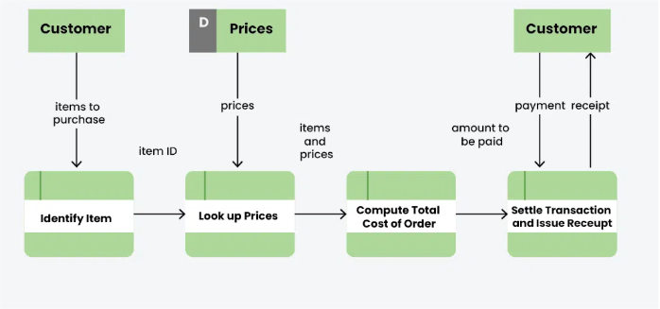
Figure 4: Data flow Diagram

CHAPTER FOUR:

SYSTEM ANALYSIS, DESIGN, AND IMPLEMENTATION

4.0 Introduction
The chapter outlines the methods used to assess the system requirements, design the system architecture, and implement the functional components that support the buying and selling of automobile spare parts.

4.1 Introduction

4.1.1 User login
Basic login and registration screens with email/password authentication and account recovery functionality. Design favors user simplicity and ease of use for low digital experience users. One can either login as the buyer or the seller. The user will first sign up
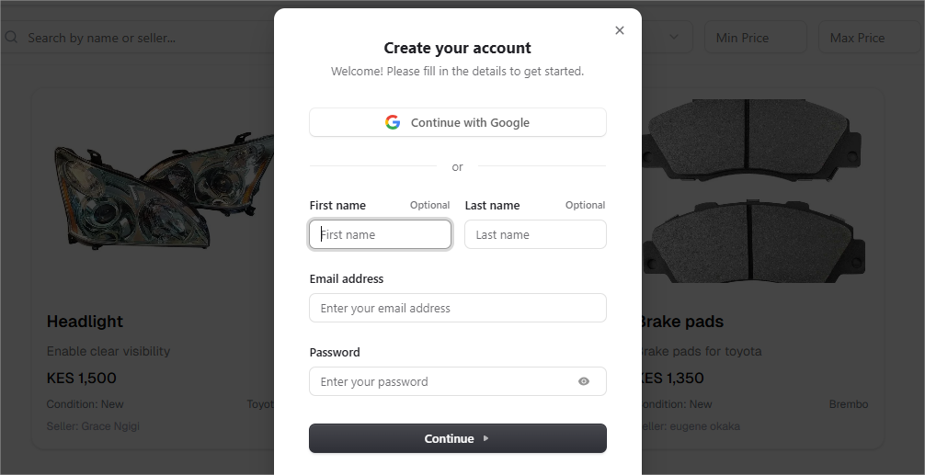
Figure 5: User login

4.1.2 Login as Buyer or Seller
In this display the user can select either buyer or seller after filling all the required details.
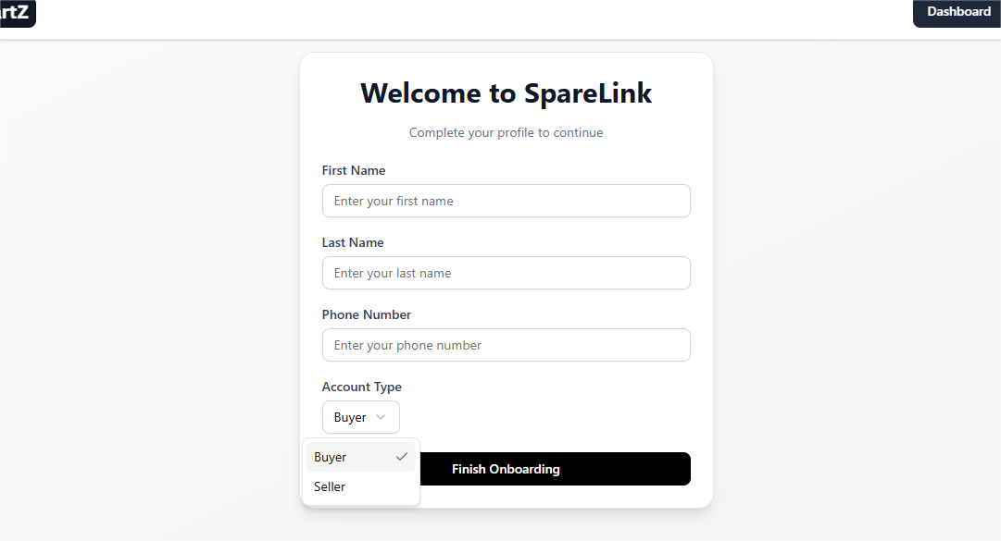
Figure 6: User login either buyer or seller

4.1.3 Product Display
Product display describes all the products listed by the seller according to their prices, either used or new and a small description about the product.
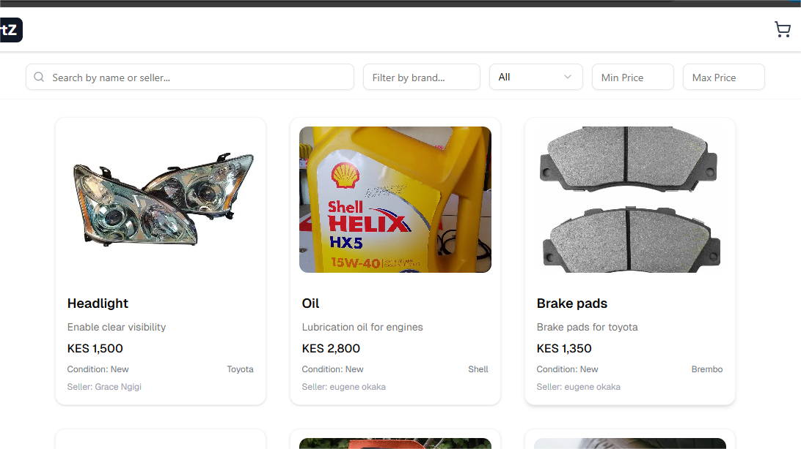
Figure 7: Product Display

4.1.4 Seller Display
In this display it shows what the seller has placed in their inventory according to whether new or used, their prices and a small description of the product.

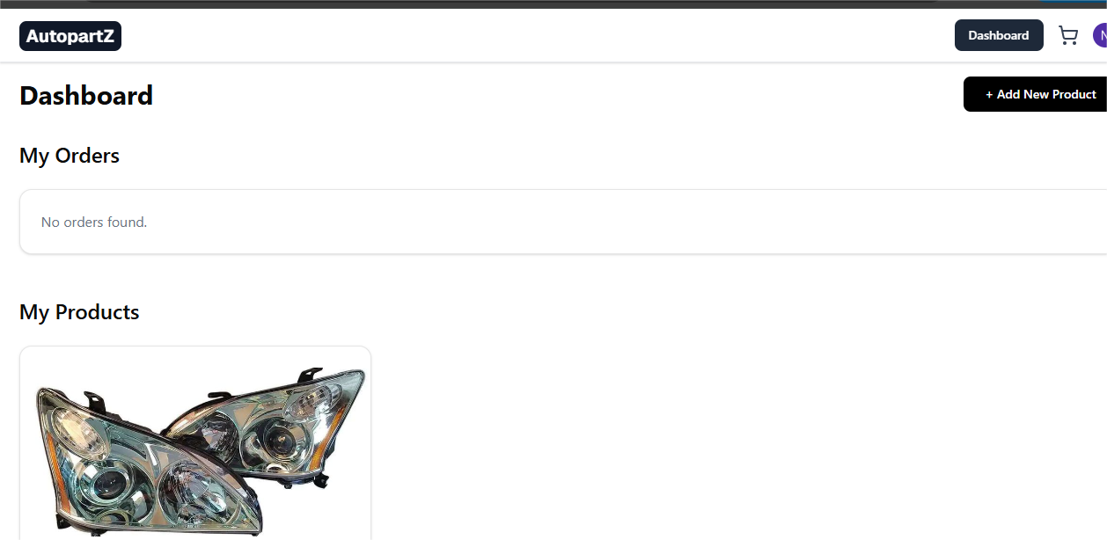
Figure 8: Seller Display

4.1.5 Buyer Display
This displayes what the buyer has purchased and added to their cart.

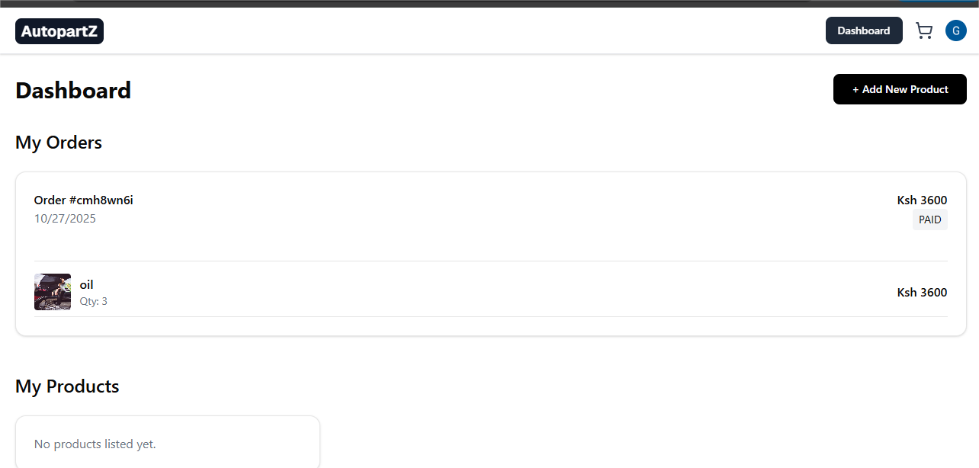
Figure 9: Buyer display

CHAPTER FIVE

CONCLUSION AND RECOMMENDATIONS

5.0 Introduction
This chapter presents the final overview of the Auto Partz Web Application System. This section covers the ends made after improving and testing of the framework. Suggestions were made with respect to utilization of the framework. It is also features the future works that can be done on the system.

5.1 Conclusion
The Auto Partz System successfully meets the objectives stated at the beginning of the project. It provides a convenient, efficient, and transparent marketplace for automobile spare parts. Buyers can browse a wide range of products from different sellers, compare prices, and access product details quickly, while sellers can easily upload and manage their spare parts inventory.

5.2 Recommendations
The Auto Partz System can be further improved by integrating secure online payment options such as PayPal to allow seamless transactions directly on the platform. Additionally, implementing a review and rating system would help build user trust by enabling buyers to provide feedback on products and sellers. Enhancing security through stronger encryption, two-factor authentication, and CAPTCHA would further protect user accounts. Improving search and filtering options such as by brand, model, price, and condition would enhance usability, while ensuring mobile responsiveness or developing a dedicated mobile app would make the system more accessible across a wider range of devices.

5.3 Future Work
Future enhancements of the Auto Partz System could include adding real-time chat support to enable direct communication between buyers and sellers, as well as implementing an inventory tracking system that automatically monitors stock levels and sends low-inventory alerts. Integrating delivery or logistics services would streamline product shipment for sellers, while incorporating AI-based product recommendations would help buyers discover relevant spare parts based on their search behavior. Additionally, developing an analytics dashboard would provide sellers with valuable insights into sales trends, customer preferences, and overall product performance.

REFERENCES
Auto Xpress which is based in Nakuru https://auto-xpress.co.ke/#!/l/nakuru/nakuru-kisumu-rd/nakuru
Best care mechanics garage in Nakuru https://bestcaremechanicgarage.co.ke/area/nakuru/
Scribd which is a documentation about a garage https://www.scribd.com/document/777728621/Garage-Management
Ebay Motors which is a global auto parts web site https://www.ebay.com/b/Auto-Parts-and-Vehicles/6000/bn_1865334

APPENDIX
Github https://github.com/ngigigrace647-del/Auto-PartZ.git

